**How much cover crop growth is needed for weed control? A review of Corn Belt research and opportunities in Nebraska**

**Andrea Basche – Assistant Professor in Cropping Systems**

***This project is also a collaboration with***

**David Weisberger & Virginia Nichols – Iowa State University Department of Agronomy**

**Sarah Carlson – Strategic Initiatives Director, Practical Farmers of Iowa**

**Nilovna Chatterjee – Postdoctoral Research Associate, University of Nebraska-Lincoln**

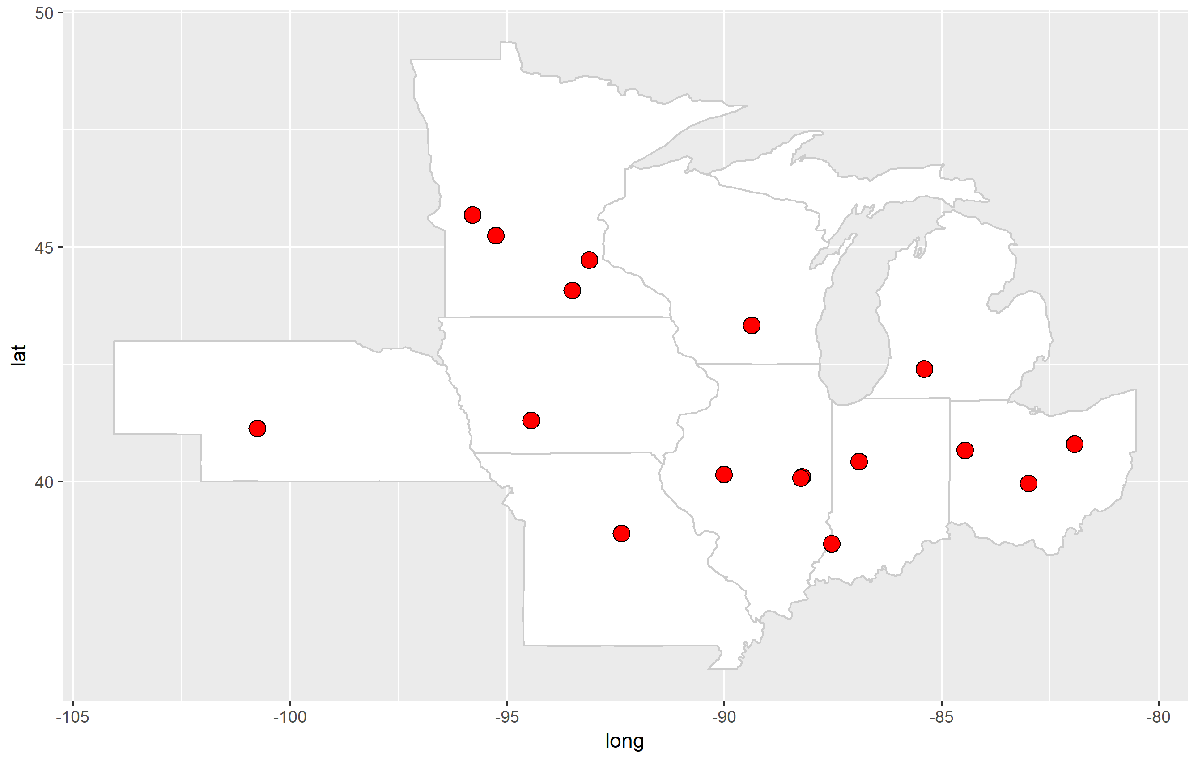

**Figure 1. Experimental locations included in our systematic review of weed control from cover crops in the Corn Belt. Overall, we have found that cover crops are more effective at reducing weed biomass compared to weed density, which could contribute to improving the efficacy of an herbicide program**

How well do cover crops control weeds and can they offset herbicide costs in corn-soybean cropping systems across the Corn Belt? We are working on a meta-analysis to answer these questions. Meta-analysis is a quantitative, systematic method to synthesize prior research. The power of such an analysis is that it allows us to investigate overall trends of a particular treatment by combining results from many different experiments.

We have analyzed results from fifteen different experiments across nine states (Figure 1), including one in Nebraska. In order to be included in our analysis, experiments needed to fit specific criteria: 1. A fall planted cover crop was grown before corn or soybean; 2. All other management – minus the inclusion of a winter cover crop – needed to remain constant; 3. Experiment was located within one of the top corn and soybean producing states of the Midwestern Corn Belt.

Overall we have found:

* Across the Corn Belt, experiments show that cover crops are generally more effective at reducing weed biomass (size of weeds) compared to weed density (amount of weeds). This suggests that cover crops may be more beneficial from the standpoint of controlling the size of weeds and thus the efficacy of an herbicide program.
* Cover crop termination method impacted the efficacy of the cover crop to control weeds. Experiments that used herbicides or a combination of herbicides and mowing to terminate, or cover crops that were winter-killed were found to be more effective at weed control than cover crops terminated solely by crimping or mowing.
* When a cover crop preceded corn, cover crop biomass of approximately 3500 lbs/acre tended to consistently reduce weed biomass and weed density. When a cover crop preceded soybean, results in our analysis were variable; some experiments showed significant weed control with smaller amounts of cover crop biomass (<1000 lbs/acre), while others had ineffective weed control with smaller or larger amounts of cover crop biomass before soybean. Effective weed control from a cover crop before soybean is pictured in Figure 2.

*Cover crops have been found to reduce weed biomass across the Corn Belt. Nebraska experiments show adequate cover crop biomass to provide weed control, although growth can vary substantially from year to year.*

* Experiments included in our analysis utilized grass, legume and mixed cover crop species. We did not find differences in the efficacy of weed control with different cover crop species. We also did not find differences in weed control if an experiment planted corn or soybean following the cover crop.

What does this mean for cover crops and weed control in Nebraska?

* The Nebraska study included in our analysis was conducted at the North Platte experiment station and on a nearby producer’s field from 2016-2017. Both sites were under no-till irrigated continuous corn management. They found between 3300-3600 lbs/acre of rye biomass reduced both weed density weed biomass by >90%. Cover crops were planted from mid-September to mid-October in these experiments and were terminated with herbicides in mid-April.
* Research collected from 2015-2017 at the South Central Agricultural Laboratory (Clay Center, NE) found that cereal rye cover crop growth ranged from 600 to >5000 lbs/acre when planted between late September and late October. The earlier planted rye, which always produced the highest amounts of biomass, was following an early or medium maturity corn hybrid. This work did not find yield differences between medium (97-day) and late-maturity (111-115-day) corn hybrids.

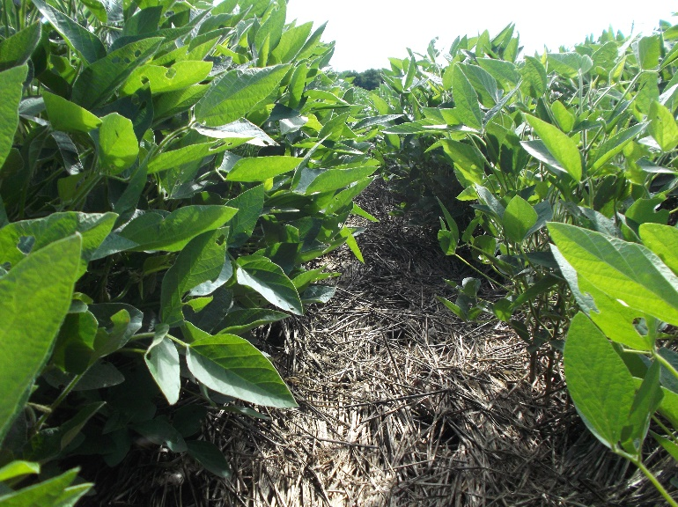

**Figure 2. Cereal rye residue can provide soil cover and weed suppression before soybean. Photo credit: Sarah Carlson.**